KOTHALA TEJOVANTH (192512063)

Experiment: 7:Analog Beamforming Analysis Using MATLAB

Aim
To analyze the performance of analog beamforming by studying beamforming gain, beam width,
and main lobe direction using MATLAB.
Objectives
1. To analyze the beamforming gain achieved by varying the number of antenna elements in
an analog beamforming system using MATLAB.
2. To compare the beam width of an antenna array for different beamforming configurations
using MATLAB.
3. To analyze the main lobe direction by steering the antenna array beam to different angles
using MATLAB.
Software Required
• MATLAB
Theory
Analog beamforming is a beam steering technique in which a single RF chain drives multiple
antenna elements through adjustable phase shifters. By controlling the phase of the transmitted or
received signals, the antenna array forms a directional beam toward the intended user, thereby
improving signal strength, coverage, and spectral efficiency. Analog beamforming is widely
employed in millimeter-wave (mmWave) communication systems due to its reduced hardware
complexity and lower power consumption.
Objective – 1
Analyze Beamforming Gain (dB)
Generate beamforming gain values for different antenna array sizes using MATLAB. Compare
how increasing the number of antenna elements improves the beamforming gain and enhances
signal strength.
MATLAB Code:
clc;
clear;
close all;
antennas = [2 4 8 16 32]; % Number of Antenna Elements
gain = 10*log10(antennas); % Beamforming Gain (dB)
figure
bar(antennas, gain)
grid on

xlabel('Number of Antenna Elements')
ylabel('Beamforming Gain (dB)')
title('Beamforming Gain for Different Antenna Array Sizes')
Expected Output
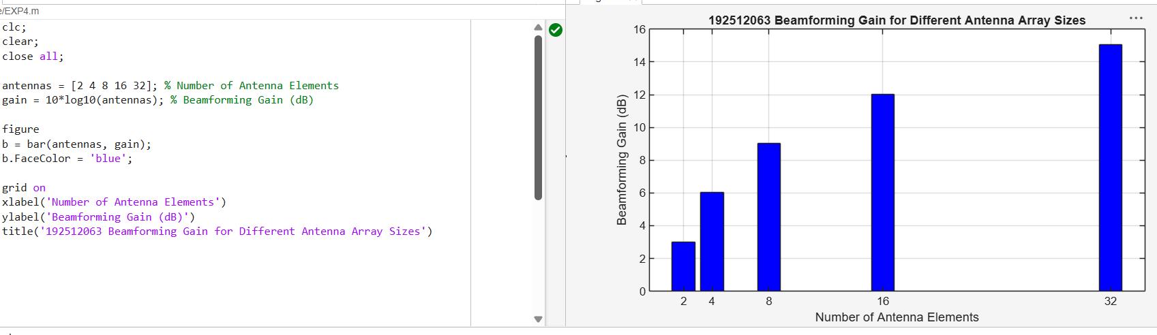

• Bar graph showing beamforming gain for different antenna array sizes.
Objective – 2
Compare Beam Width (Degrees)
Analyze the beam width corresponding to different antenna array sizes using MATLAB. Observe
how increasing the number of antenna elements results in a narrower beam, thereby improving
spatial resolution.
MATLAB Code:
clc;
clear;
close all;
antennas = [2 4 8 16 32]; % Number of Antenna Elements
beamwidth = [90 45 22.5 11.25 5.625]; % Beam Width (degrees)
figure
plot(antennas, beamwidth,'o-','LineWidth',2)
grid on

xlabel('Number of Antenna Elements')
ylabel('Beam Width (Degrees)')
title('Beam Width for Different Antenna Array Sizes')
Expected Output
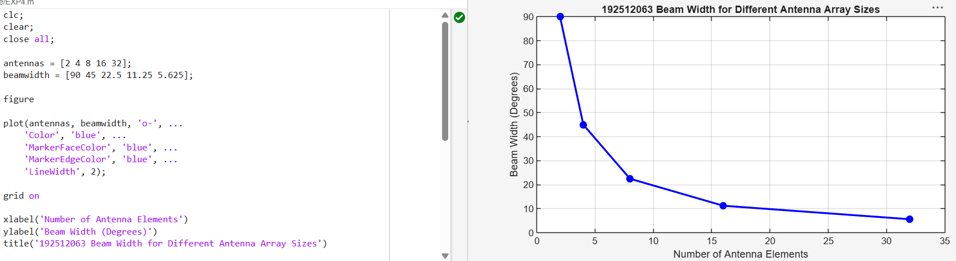

• Line graph showing beam width versus antenna array size.

Objective – 3
Analyze Main Lobe Direction (Degrees)
Simulate beam steering by varying the steering angle of the antenna array using MATLAB.
Observe the change in the main lobe direction and understand how analog beamforming directs
energy toward the intended user.
MATLAB Code:
clc;
clear;
close all;
theta = [-60 -30 0 30 60]; % Main Lobe Direction (degrees)
gain = [1 1 1 1 1]; % Constant normalized gain
figure
polarplot(deg2rad(theta), gain, 'o', 'LineWidth', 2)
title('Main Lobe Direction in Analog Beamforming')

Expected Output
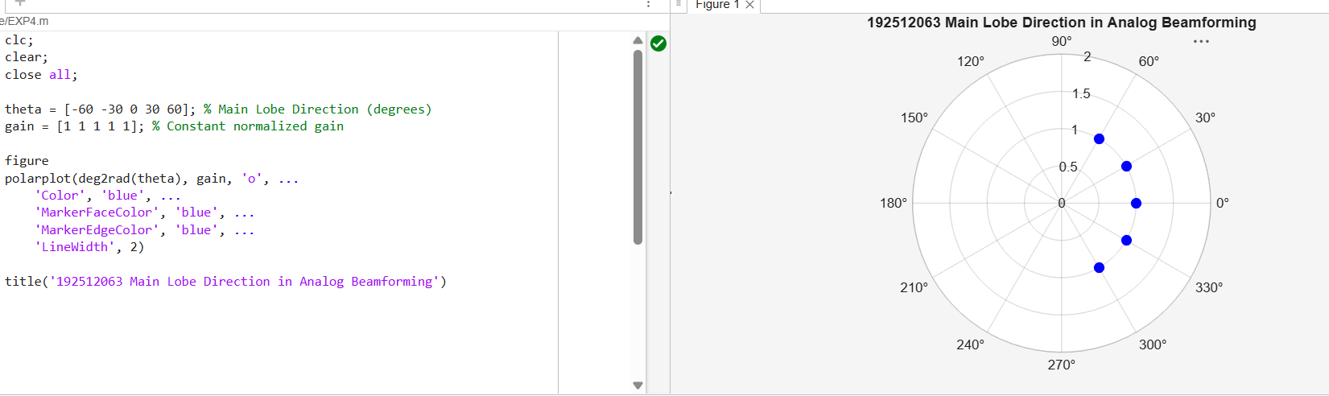

• Polar plot or beam pattern showing the main lobe steered to different angles.
Result
The MATLAB analysis successfully demonstrated the characteristics of analog beamforming. The
results showed that increasing the number of antenna elements improves beamforming gain and
reduces beam width, while phase adjustment enables the main lobe to be steered toward different
directions.

